Water Filter Corp www.waterfiltercorp.com

Blackstone / Homeguard Maxi

Installation instructions

- Filter must be mounted vertically with the large arrow showing the flow going downwards
- Assemble the End Cap Clamps and place them around the end cap at each end of the body to retain the cap. Tighten the supplied Clamp bolts.
- Using a small amount of PTFE plumbers tape fit the ½” Plug to the centre threaded outlet at each end.
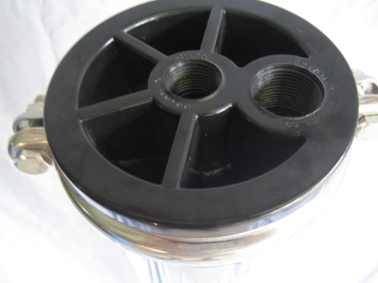
- Water inlet (untreated water) is to be connected to the top of filter. The fitting is a female ¾” BSP. NOTE: tightening of the connection to this fitting must not exceed 65lbs in. (7nm) It is suggested that a flexible ¾” SS hose fitting be used here to facilitate easy element changing.
Blackstone HomeGuard
- Water outlet (treated water) is to be connected to the bottom. Connection notes apply as above.
- Filter must be installed between the pump and the building (Tank Water) or the meter and the building (Town supply connection).
- Note where filter is installed in a town water supply it must be fitted by a licensed plumber.
- Mounting brackets are supplied for use if required.
- Run water from nearest tap until water runs clear of carbon sediment, air bubbles shown as cloudiness in a glass of water will be evident for about 24hrs.
- The Carbon, AA101 and AquaZEL© elements if fitted will require changing after approximately six months. These figures are a guide only as initial water quality and usage are unknown.
- The 1 micron bag element supplied can be replaced as required (6 months), depending on input water quality. The used bag can be recycled by washing and sterilising (soak in household bleach) DO Not Scrub as it will block 1 micron holes in bag, note washing may impede flow and washing more than once is not recommended.

Replacing MAXI Filter Elements
To replace the bag in a filter, first turn off the pump or mains. Undo the top clamp, quickly turn on the pump or mains and this will push the top cap out of the body. Be ready to turn the pump or mains off as soon as the top cap is free. Remove the 1micron bag or element(s) and replace as required.
After replacing the bag filter, push the top cap into place and relace the clamp.

To replace the other elements, Undue top clamp and remove top plastic cap by prying gently with screw driver, remove bag filter and lift out used elements, the new elements can now be replaced through the top of the filter (Note the correct replacement order below for your filter). Hold the new element in both hands and stretch it, making the element narrower where it first enters the top of the filter, the element will then easily slide in past the bag retaining ring.

- The Blackstone filter contains 2 BSC104s Carbon Elements + a 350mm 1µ Bag filter

- The HomeGuard MAXI Filter contains 1HMG104s Carbon element + 2 BSC AA101 Activated Alumina Element + a 200mm 1µ Bag Filter.

- The HomeGuard MAXI Ionising filter contains 1 HMG104s Carbon Element + 1BSC AA101 Activated Alumina Element + 1 HMG AquaZEL© element + 1 KDF55 Ionising element + a 200mm 1µ Bag Filter

Note the order of the elements for your particular filter are shown below.

HomeGuard
MAXI Filter
Blackstone
Filter
HomeGuard Ionising
MAXI Filter

